Page 72

36).
a.
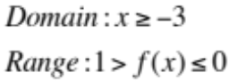
b.
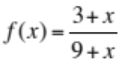
c.
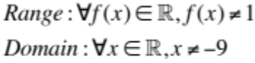

Page 76

8).
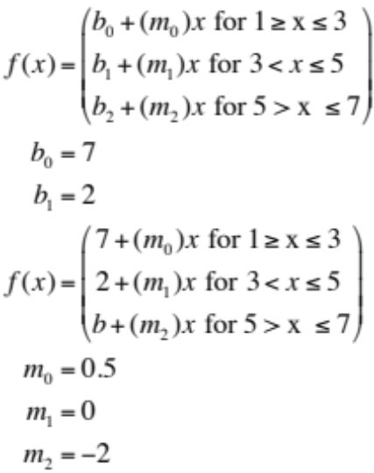
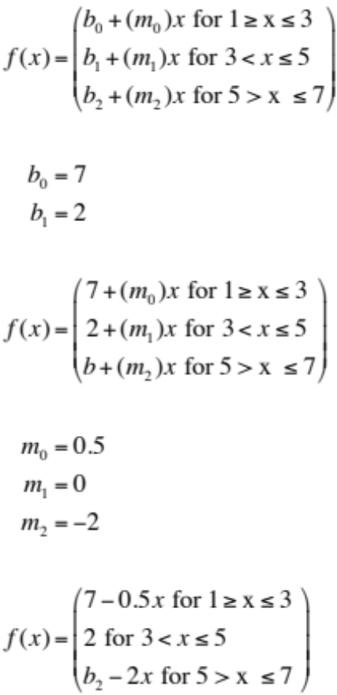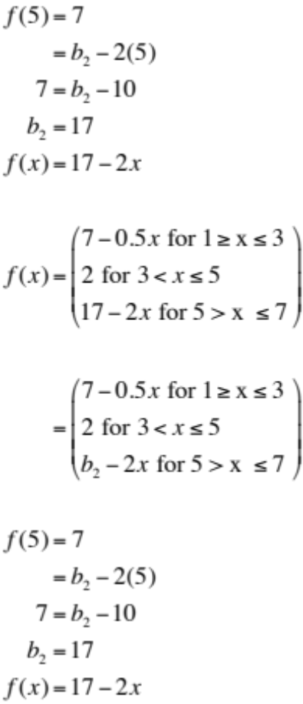

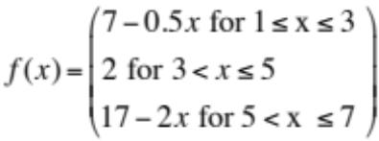

14).

a).
Length in ¼ miles | 0 | 1 | 2 | 3 | 4 | 5 | 6 | 7 | 8
Costs in dollars | 2.5 | 2.9 | 3.3 | 3.7 | 4.1 | 4.5 | 4.9 | 5.3 | 5.7

b). 

c). 7/4 mile

d).
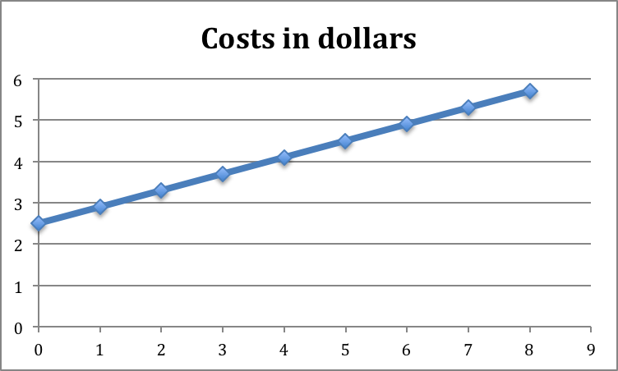

16).

18).
a). $1.01

b).
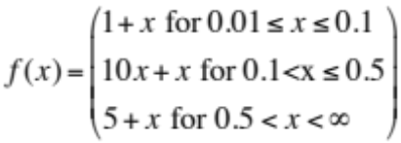

c).
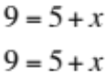

d).

Hw 02 Due 02/19/14 or 02/26/14

Group of problems starting on page 66: # 10, 30, 34, 36.

Group of problems starting on Page 72: # 22, 28, 36.
In # 22, formula function is 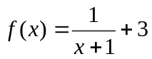

Group of problems starting on Page 76: # 8, 14, 16, 18
In # 14 consider that if you get in the taxi and do not travel any distance, you would be charged $0. This question is similar to Example 4 from my notes, Lesson 2.3 (posted.)
Notice that #18 has parts (a), (b), (c), and (d).

